**Playtesting**

In the process of testing and evaluating the entire game about Math Games through the survey showed that the qualitative and quantitative of a game is necessary. According to Hayes and Hayes (1998), it can be seen through survey questions that the player's potential is an important object that game makers want to target. From there, it is possible to devise strategies to turn them into loyal and loyal customers. Besides, Bowen and Chen (2001) emphasized that outreach takes a large amount of time to data gathering and analyzing a player's habits with the game maker's products.

The math game system is based on the calculation foundation of calculations (multiplication, division, addition, subtraction). With the elements, the dramatic details in each game genre make players more passionate and speed up calculation. Can create competition with other players or set goals for yourself. Also, this game genre helps to develop the thinking of children and adults.

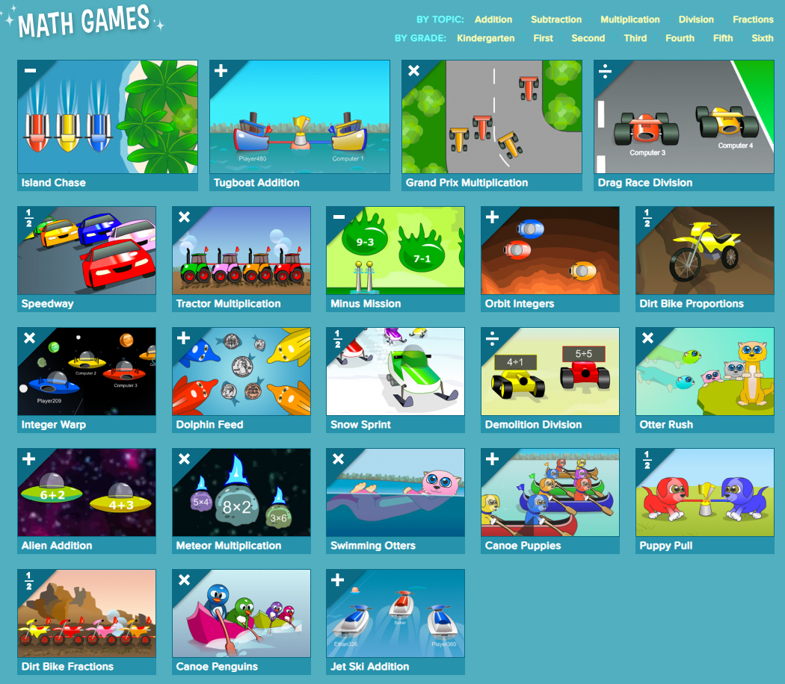

According to the 4-person survey, 25% were players for less than 5 minutes, 50% were playing for 5-10 minutes, and only 25% were playing for more than 10 minutes. That shows that this game genre also attracts players to the gameplay, the ability to reflect.

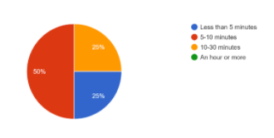

Besides, Experience: when playing this game, players agree 100% with the question "Do you get any experience while playing this game?" Furthermore, Contribution: shows that the acquisition of feedback from customers about this game genre is 100% to change the gameplay mode and player factors.

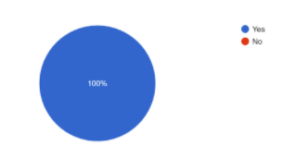

Furthermore, the strength of this approach effectively connects with customers to understand the individual needs and preferences of the player. It is less expensive but also provides some diverse ideas in the marketing strategy, so that the company can develop and improve the right product strategies before launching to match each demographic group. Besides, this method has shortcomings such as the inability to study the competitor's strategy without understanding the customer segment. According to Bertsimas and Mersereau (2007), finding a suitable marketing strategy is a competitive test in the industry to be. Moreover, it is difficult to advertise game genres and their images because it is simply to survey customers' needs without promoting their image.

Finally, to further develop game product image advertising and how to receive customer feedback in the future, it is still necessary to combine different marketing strategies such as customer surveys, research. Competitors advertise the strategy of the product and engage customers through social media channels. From there, it is possible to create a separate community for the product and the number of followers through social networking sites.

**References:**

Hayes, E. and Hayes, E. (1998) *Measuring customer satisfaction: Survey design, use, and statistical analysis methods*. Milwaukee^ eWisconsin Wisconsin: ASQC Quality Press.

Bowen, J. and Chen, L. (2001) The relationship between customer loyalty and customer satisfaction. *International journal of contemporary hospitality management*.

Bertsimas, D. and Mersereau, A. (2007) A learning approach for interactive marketing to a customer segment. *Operations Research*, *55*(6), pp.1120-1135.

Math Games(2020)  *CoolMath4Kids*. Available from: https://www.coolmath4kids.com/math-games [Accessed 1 December 2020].